ALL INDIA INSTITUTE OF SPEECH AND HEARING
अखिल भारतीय वाक एवं श्रवण संस्थान
DEPARTMENT OF SPECIAL EDUCATION
विशेष शिक्षा विभाग
September Monthly Report 2016
- ACADEMIC ACTIVITIES
- Short-term Training Programs: NIL
- Faculty report
Dr. M. Pushpavathi
- Supervised the preparation of Gombe mane for Dasara celebration
- Attended court on 7.9.12 due to official work
- Supervised the work related to material preparation related to different conceptsin different languages.
- Had a discussion with HOD clinical services related to speech language therapy.
- Arranged one minute program for students as a part of Hindi week on 20.9.16.

Name of the Faculty |  | Dr. Alok Kumar | Dr. G. Malar | Dr. Prithi Venkatesh | Dr. P. Vijetha
Clinics
No. of cases evaluated at SEA-U |  | 05 | 10 screening | 13 | 04  (K-1,H-1, M-2)
No. of cases supervised individually |  | 0 | 4 (Tamil PPEP/ GEGCS) |  | NIL
No. of groups supervised |  | 09 | 10 groups –59 children | 10 | 08
No. of meeting with parents |  | 09 | 7 (Preschool)  1 (Tamil PPEP/ GEGCS) | 2 | 08
Educational Guidance |  | 02(01 Hour) | 11 clients – 11 sessions |  | 02 children  (School Readiness Test)  (Two hours)
Academic (Classes not commenced for the month of June 2016)
Classes taken
B.Ed.  Spl.Edn(HI) | Theory | 26 Classes | 22 sessions | 10 classes | 17 hours
B.Ed.  Spl.Edn(HI) | Practical | 28 hours | 25:30 hours supervision + correction of unit/ lesson plans, blueprints, etc. | 8 days (40 hours) | 46 hours (6 days*3 hours)  (Special School visit) (11 days* 2.5 hours)  Lesson planning and Practice teaching and Indian Sign language
DECSE(HI) | Theory |  |  | 15 classes | 15 hours
DECSE(HI) | Practical |  |  | 4 days ( 4 hours) | 92 hours (23 days * 4 hours) (Paper II)  Observation sessions
Any other
Research
Paper published |  | 01
Paper in press/ in progress |  | 03 |  | 01
Paper presentation
ARF Project |  | 01 proposal Submitted | 01 |  | - On 19th September 2016, submitted revised report incorporating the reviewer suggestions of ARF project titled “Attitudes of In-service Educators towards Inclusive Education”.  ( Eight Hours)  - “Efficacy of self-learning adapted social studies lessons in Kannada and Telugu for children with hearing impairment at Secondary School Level”.  Duration: One year  Date of  commencement:  8th January 2016  Budget sanctioned:  Rupees 3,25,000/  Finalized Three chapters  Peparing final draft of Results and discussion chapter.
Thesis Evaluation/Project Review |  | One M.Phil thesis evaluated
Any other
Meeting held |  |  | 2 (monthly meeting with I & II B.Ed. students) |  | On 14th September 2016, a initial meeting was held with the team members as a part of mainstream school adoption program and also work was distributed among the Team (One hour)
Meeting attended |  | 02 | 2 – Meetings with HOD |  | - On 7th September 2016 met HOD and discussed on the work to be carried out under “Mainstream school adoption program”  (one hour)  - Started preparing PPT Slides for Orientation program as a part of Mainstream school adoption Program  (Two hours)  - On 14th September 2016, attended Peer Evaluation of ENT Department.  (one hour)  - On 20th September 2016, attended BOE work from 10:00 to 4:00pm  - On 22nd and 30th September 2016, attended JC  (Two hours)
AV preparation |  |  | 1 PPTs on Visual Arts in Education for II B.Ed.Spl.Ed. (HI) students & 4 on orthopaedic handicaps for I B.Ed.Spl.Ed. | Coordinating pre-school video recording activity. Completed video recording for two groups.
Brochures
Orientation Programme |  |  |  | Oriented Audiology Clinical Staff and Speech Language Sciences Staff regarding services offered in the Department of Special Education and preschool (2 hours)  Oriented staff of Department of Special Education for E3 on the topic ‘ An analysis of errors made by children with hearing impairment in Mathematics on 20th September 2016.
Workshop |  |  |  | - Prepared and submitted proposal for traditional games celebration for Children’s day.  - In this connection, indented for local purchase of items.  - Attended workshop on ‘Çreative Art Therapy’  - Served as a chairperson for Stage Decoration and management committee on occasion of Inauguration of Sumeru and for workshop on creative art therapy. From 29th August 2016 to 2nd September 2016. | - Prepared and submitted proposal for Health camp celebration for Children’s day.  - Attended National Workshop on “Creative Art Therapy when Words are not enough” from 29th August to 2nd September 2016.  - Served as one of the coordinators for conducting “one minute game” students for Hindi week held on 20th September 2016
Roles & Responsibilities
Co-ordination |  | Infant & Toddler Unit | SEA-U  EduTechLab  Research & Database Unit |  | Service for School aged children
Member secretary |  | Preschool | Services for School-Aged Children | SEA -U | Service for Infant and Toddlers
Member in |  | SEA-U | School Adoption Team |  | SEA -U
Mentor |  | M.Sc. -1st Year -Audiology
- Orientation Programs: NIL
- Clinical/Special Educational services- Observation Posting of Students from other Institutes: NIL
- Seminars/Conferences/Workshops: NIL
- In- house training Programs:

E³ : Empowering Educators in Education: 01
Theme/Topic | “ An Analysis of Errors made by Children with Hearing Impairment in Mathmatics” by Dr. Prithi Venkatesh
Coordinator | Mr. Suresh C. B.
Objectives | To Educate Educators in Education
Organized by Department/Section/Unit | Department of Special Education
Targeted Audience | Special Educators
Date | 20.09.2016
Photo | 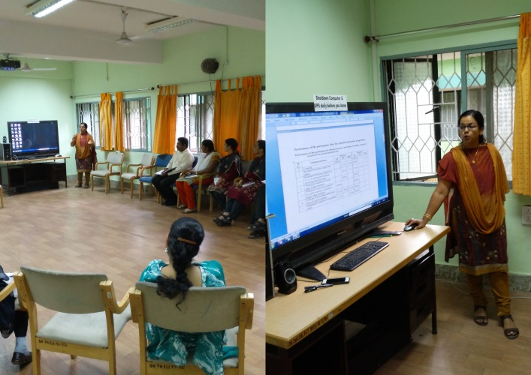

- Staff Enrichment Programs (SEP’s) : NIL
- Guest Lectures :
Dr. P. Vijetha
- Served as a Resource person for “Monthly Public lecture” on 24th September 2016 and delivered a lecture on “Adaptation of a school lesson for children with hearing impairment”. Thirty participants (30) attended the program.
- Invited Talks: NIL
- Development of Materials to Support Learning-
- Service in Academic bodies of other Organizations- NIL
- Membership in Professional Organizations/Associations - NIL
- Participation in Committees/Taskforce and Panels setup by other organizations/agencies-NIL
- Any Other(Please Specify) - NIL
- RESEARCH ACTIVITIES
- Research Projects
- Completed Research Projects
- New Research Projects:
- On-going Research Project : 01 (ARF)
- Doctoral and Post-Doctoral Programs
- Degree Awarded
Thesis awarded:
- Thesis Submitted:
- Under Progress: 04
Name of the student | Title | External/internal | Guide | Date of initiation | Status
Deepak Kr. Tripathi | Uttar Pradesh kevisheshthathasamekithvidyalayon me adhyanthathshravanachambalankokibhashavikaskatulnathmakahyan | External | Dr.Alok Kr. Upadhyay | 2011 | In Progress
VijetaRai | Effect of peer tutoring and curriculum adaptation for  D.H.H. children in inclusive steps: an experimental study | External | Dr.Alok Kr. Upadhyay | 2012 | In Progress
Neetu  Pandey | A study on communication options for Deaf & Hard of  Hearing used in Inclusive and Non-inclusive set up. | External | Dr.AlokKr. Upadhyay | 2012 | In Progress
Niranjan  Singh | Uttar Pradesh keSamavesibatavaran main adhayanratshravanachamchatrao main manobagyanikprakriyasambandhi vicar se utapansakshiksamasayaonkaadhyan. | External | Dr.Alok Kr. Upadhyay | 2012 | In Progress
- Research Papers presented at National/International Conferences/Seminars.
- Research Papers Published(in APA format):NIL
    - Papers published in Conference/Seminar Proceedings
    - Research Papers in press- NIL
    - Research Papers published in Journals:
    - No. of in-house journal articles:
    - Books published.
      - Bacchon ke liye kathayein aur kavitayein in Hindi prepared by Dr. Kadambari N, Mr. Harish Kumar and Mr. Murshidul Alam
      - Rastriya aur sanskritik tyohar in Hindi prepared by Dr. Alok Kumar Upadhyay, Mr. Harish Kumar and Mr. Murshidul Alam
      - National and traditional festivals in Kannada prepared by Ms. Latha C. and Ms. S.B. Leelarani
      - National and traditional festivals in Malayalam prepared by Mr. Suresh C. B. & Ms. Anjana.K
      - Public places in Kannada prepared by Ms.Shobha B.N., Ms.Leena C. C, Ms.Sumana H. P.
      - Rhymes & Stories in Kannada prepared by Mr. Subramanya K. R., Mr. Sharanaiah M. M.

- Book chapters published(in APA format)
Yathiraj, A. & Malar, G. (2016). Unit V: Rehabilitation. In S. R. Savithri (Ed.) Self Learning Materials for DHLS: Course V – Management of Communication Disorders I. Mysuru, India, AIISH.
Yathiraj, A., Malar, G., Savithri, S. R., & Swapna, N. (2016). Unit IV: Educational Issues. In S. R. Savithri (Ed.) Self Learning Materials for DHLS: Course VI – Management of Communication Disorders II. Mysuru, India, AIISH.

- Books in press :
- Books/Manuals/Seminar Proceedings edited
- Journal Editorship
- Scholarly Reviewing Activities
- Reviewer for Scholarly Journals
- M.S.Ed (HI) Dissertations Guided by Faculty
- SPECIAL EDUCATIONAL SERVICES
- Pre-School Training and Special Education
  - Monthly Statistics Special Educational Services

S. No. | Nature of Services (I/C)
Special Educational Assessment Services (Dr. G. Malar)
 |  | Nature of Special Need  Language |  | ASD / PDD NOS | Hearing Loss |  | Intellectual Disability | Learning Disability | Motor Problems | Multiple Disabilities |  | Others | No. of Clients | No. of Sessions | Total No. of Sessions
1. | Screening & Referral | Kannada |  | 1 | 4 |  | 3 | 1 | 1 | 3 |  | 1 | 14 | 14 | 29
1. | Screening & Referral | Malayalam |  | 2 | 2 |  | - | - | 2 | 5 |  | 1 | 12 | 12 | 29
1. | Screening & Referral | Hindi |  | 1 | - |  | - | - | - | - |  | - | 1 | 1 | 29
1. | Screening & Referral | Urdu |  | - | - |  | - | - | - | - |  | - | - | - | 29
1. | Screening & Referral | English |  | - | - |  | - | - | - | - |  | - | - | - | 29
1. | Screening & Referral | Telugu |  | - | - |  | - | - | - | 1 |  | - | 1 | 1 | 29
1. | Screening & Referral | Tamil |  | - | - |  | - | - | - | - |  | - | - | - | 29
1. | Screening & Referral | Any Other |  | - | - |  | - | - | - | - |  | - | - | - | 29
1. | Screening & Referral | Total No. of Clients |  | 4 | 6 |  | 3 | 1 | 3 | 9 |  | 2 | 29 | 29 | 29
2. | Assessment & Report | Kannada |  | - | - |  | 2 | 1 | - | - |  | - | 3 | 03 | 03
2. | Assessment & Report | Malayalam |  | - | - |  | - | - | - | - |  | - | - | - | 03
2. | Assessment & Report | Hindi |  | - | - |  | - | - | - | - |  | - | - | - | 03
2. | Assessment & Report | Urdu |  | - | - |  | - | - | - | - |  | - | - | - | 03
2. | Assessment & Report | Telugu |  | - | - |  | - | - | - | - |  | - | - | - | 03
2. | Assessment & Report | Tamil |  | - | - |  | - | - | - | - |  | - | - | - | 03
2. | Assessment & Report | Any Other |  | - | - |  | - | - | - | - |  | - | - | - | 03
2. | Assessment & Report | Total No. of Clients |  | - | - |  | 2 | 1 | - | - |  | - | 3 | 03
2. | Places from which seen: (1)Karnataka: 14 (2)Kerala: 11 (3)AP: 1 (4)TN: Nil (5)Other Parts of India: 1 – Bihar (6)Any other: Nil
2. | Age groups seen:(1)Birth to 2.5yrs: 3 (2)2.5+ to 6 yrs: 18 (3)6yrs+ to 16 years: 4 (4)16yrs+: 2
2. | Total No. of Referrals: (1)Educational Assessment: 3 (2)Educational Guidance: 1 (3)PIP: 7 (4)PPEP/ PBC/ GECS: 14 (5)CSS/IEP/NFE/DET: 3 (6) Any Other Services at AIISH: Nil (7) Any Other Services Outside AIISH: 3
2. | No. of Reports Issued: (1) Early Development Skills: Nil (2) School Readiness: Nil (3) Curriculum-Based Assessment: 1 (4) Post-School Preparedness: Nil
3. | On-going Assessment (as part of service delivery) |  | Figure:  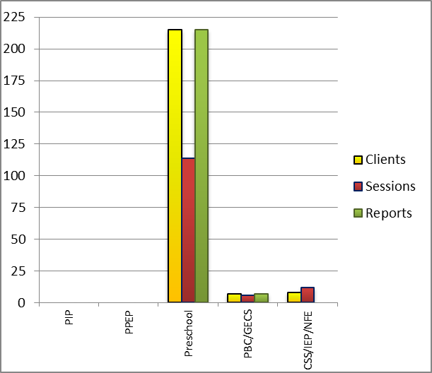
 | Details of Assessments |  | No. of Children |  |  | No. of Assessment Sessions |  |  |  |  | No. of Reports
 | As part of Parent-Infant Programme: |  | Nil |  |  | Nil |  |  |  |  | Nil
 | As part of Preschool Parent-Empowerment Programme: |  | Nil |  |  | Nil |  |  |  |  | Nil
 | As part of Preschool Training Programme: |  | 215 |  |  | 38 |  |  |  |  | 215
 | As part of Preschool Bridge Course Programme: |  | 07 |  |  | 02 |  |  |  |  | 07
 | As part of CSS/ IEP/NFE: |  | 14 |  |  | 28 |  |  |  |  | Nil

Parent-Infant Programme – PIP (Birth to 2 ½ years)
Early stimulation programme for infants & toddlers with communication disorders | Language | HL | IC | CP | ASD | MD | LD | DD | Total No. of clients | Total No. Of sessions
 | Kannada | 11 | -- | 2 | 1 | 03 |  | 03 | 20 | 85
 | Malayalam | 03 | 03 |  |  | 02 |  | 08 | 16 | 69
 | Hindi | 03 | -- | -- | -- | -- | -- | -- | 03 | 14
 | English | -- | 01 | -- | -- | -- | -- | -- | 01 | 08
 | Telugu | -- | -- | -- | -- | -- | -- | -- | 00 | --
 | Tamil | -- | -- | -- | -- | -- | -- | -- | 00 | --
 | Total |  |  |  |  |  |  |  | 40 | 176
Specific age range: NIL
No. Of New clients enrolled: 04
No. discharged : NIL
No. discontinued: NIL
No. of Promoted to next level:

Preschool Parent Empowerment Programme – PPEP (Ms. Kumudha R.):
Buffer programme for children awaiting for preschool admission | Language | HL | ID | CP | ASD | MD | LD | DD | Total No. of clients | No. Of sessions
 | Kannada | 16 | 26 | 00 | 05 | 00 | -- | -- | 47 | 38
 | Malayalam | 02 | 05 | 03 | 04 | 01 | -- | -- | 15 | 38
 | Hindi | 03 | 01 | -- | -- | -- | -- | -- | 04 | 38
 | English | -- | 01 | -- | -- | -- | -- | -- | 01 | 19
 | Telugu | 08 | -- | -- | -- | -- | -- | -- | 08 | 19
 | Tamil | 04 | -- | -- | -- | -- | -- | -- | 04 | 19
Total |  |  |  |  |  |  |  |  | 79 | 171
No. of clients promoted to the next higher level of service: NIL
No. discharged : NIL
No. discontinued: 07

Services for Preschool-aged Children (2+ to 6 years)
Group Educational Guidance & Counselling Services – GEGCS (Mr.Rajkumar.R): Non-formal preschool training children with communication disorders for schooling | Language | HL | IC | CP | ASD | MD | LD | DD | Total No. of clients | No. Of sessions
 | Kannada | -- | -- | -- | -- | -- | -- | -- | -- | --
 | Malayalam | -- | -- | -- | -- | -- | -- | -- | -- | --
 | Hindi | -- | -- | -- | -- | -- | -- | -- | -- | --
 | English | -- | -- | -- | -- | -- | -- | -- | -- | --
 | Telugu | 2 | 2 | 1 | 2 | 1 |  |  | 8 | 19
 | Tamil | -- | -- | -- | -- | -- | -- | -- | -- | --
Total |  |  |  |  |  |  |  |  | 8 | 19
No. discharged : NIL
No. discontinued: NIL

Curricular Support Services – Supportive training to augment education in mainstream school/ other educational programmes |  | Language |  |  | HL |  |  | MR/CP/Down’s/LD |  | PDD |  |  |  | Total No. of clients |  |  | No. Of sessions
 |  | Kannada |  |  | 08 |  |  | 11 |  | 00 |  |  |  | 19 |  |  | 98
 |  | Malayalam |  |  | 01 |  |  | 03 |  | 00 |  |  |  | 04 |  |  | 19
 |  | Hindi |  |  | 02 |  |  | 02 |  | - |  |  |  | 04 |  |  | 20
 |  | English |  |  | - |  |  | 02 |  | - |  |  |  | 02 |  |  | 08
 |  | Telugu |  |  | - |  |  | - |  | 01 |  |  |  | 01 |  |  | 06
 |  | Tamil |  |  | -
Total |  |  |  |  |  |  |  |  |  |  |  |  |  | 30 |  |  | 151
Individualised Educational Programme (IEP) – Training in functional academics for out of school individuals |  | Language |  | HL |  |  | MR/CP/Down’s/LD |  |  |  | PDD |  | Total No.of clients |  |  | No. Of sessions
 |  | Kannada |  |  |  |  | 04 |  |  |  |  |  | 04 |  |  | 10
 |  | Malayalam |  | 01 |  |  | 03 |  |  |  |  |  | 04 |  |  | 07
 |  | Hindi |  | - |  |  | - |  |  |  | - |  | - |  |  | -
 |  | English |  | - |  |  | - |  |  |  | - |  | - |  |  | -
 |  | Telugu |  | - |  |  | - |  |  |  | - |  | - |  |  | -
Total |  |  |  |  |  |  |  |  |  |  |  |  | 08 |  |  | 17
Non-Formal Educational (NFE) | Language |  | HL |  |  | MR/CP/Down’s/LD |  |  | PDD |  |  | Total No.of clients |  |  | No. Of sessions
supports – Supportive training for children/ adolescents pursuing open schooling | Kannada
 | Malayalam
 | Hindi |  |  |  |  |  |  |  | NIL
 | English
 | Telugu
Demonstration Training – Short-term demonstration to caregivers in any of the above | Language |  | HL |  |  | MR/CP/Down’s/LD |  |  | PDD |  |  | Total No.of clients |  |  | No. Of sessions
 | Kannada |  | 01 |  |  | - |  |  | - |  |  | 1 |  |  | 4
 | Malayalam |  | - |  |  | - |  |  | - |  |  | - |  |  | -
 | Hindi |  | - |  |  | - |  |  | - |  |  | - |  |  | -
 | English |  | - |  |  | - |  |  | - |  |  | - |  |  | -
 | Telugu |  | - |  |  | - |  |  | - |  |  | - |  |  | -
 |  |  |  |  |  | Total |  |  |  |  |  | 1 |  |  | 4

Library of Books & Toys – LiBoToy (Ms. P. V. Ramanakumari & Ms. P. V. Manjula): Services issuing educational toys & books for home-based training | Total number of members enrolled - 66  No. of new members: - 17  Amount – 850/-  Total number of sessions –26
 | Age group | Total number
 | 0-2.6 yrs | 4
 | 2.6-4 yrs | 5
 | 4.0-6yrs | 52
 | 6 yrs and above | 5

Preschool Training (Ms. Prithi Venkatesh):Preparatory programme for schooling providing training in self-help, cognitive, language and (pre) academic skills, Preschool Bridge course
Language & Disability | No. of Groups | No. of Children
 |  | MALE | FEMALE
Kannada ID | 12 | 18 | 13
Kannada MD | 12 | 7 | 3
Kannada ASD | 12 | 3 | 0
Kannada Others | 12 | 11 | 4
Kannada HI | 10 | 42 | 38
Malayalam HI | 1 | 3 | 4
Malayalam ASD | 10 | 12 | 0
Malayalam MD | 10 | 7 | 8
Malayalam ID | 10 | 10 | 8
Malayalam others | 10 | 3 | 1
Hindi HL | 1 | 5 | 1
Hindi MD | 2 | 2 | 1
Hindi ID | 2 | 3 | 2
Hindi ASD | 2 | 2 | 0
English ID | 2 | 1 | 1
English ASD | 2 | 4 | 1
English others | 2 | 1 | 1
TOTAL Number of children |  | 134 | 86
TOTAL No. Groups | 38 | 220
Sessions | 3040(Group wise) (20 days)

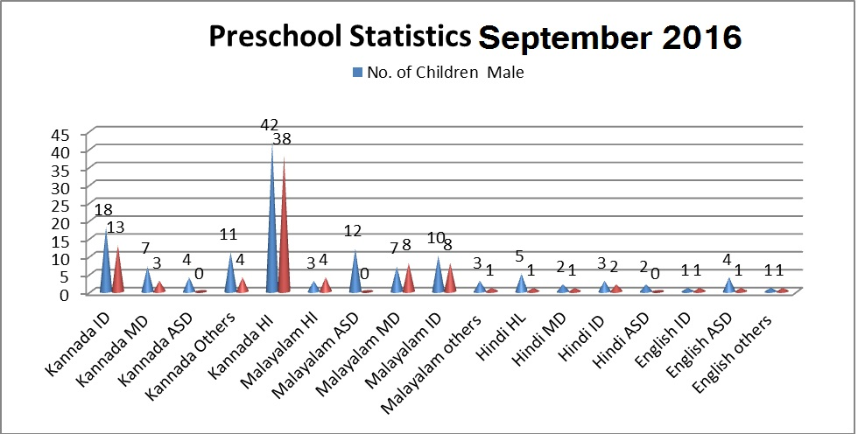

Services | Number of Clients | Number of Sessions
Guidance & Counselling | 29 | 33
Co-Curricular Training | 221 | 54
U-SAFE | 43 | 24
Supports for Empowering Caregivers
Name of Training Unit | No. of Parent  Beneficiaries | No. of Sessions | Content of Training
Caregiver Computer Training Unit | -- | -- | Moving mouse, painting, typing speed, internet browsing
Caregiver Literacy Training Unit | 8 | 12 | Meaningful reading and writing.
- Clinical Support Services to Patients and Family
- Details of Certificates Issued:
Details of Bonafide Certificates Issued:

Sl.No. | Nature of Special Needs in Clients | No. of Certificates Issued | Purpose
1 | DSL, HL | 02 | - For Admission for mainstream integration school.  - Open for bank account
- Clinical Electronic Services: NIL
V) CENTRAL FACILITIES
      - Library and Information Services
      - Public Information Activities
- Major Events of the Year with a brief account
- Name of the Programme/ Event: Inauguration of Gombe Mane Celebration in Preschool
- Date: 28.09.2016
- Coordinators – Ms. Kumudha R., Ms. Ramanakumari P.V., Ms. Manjula P.V.

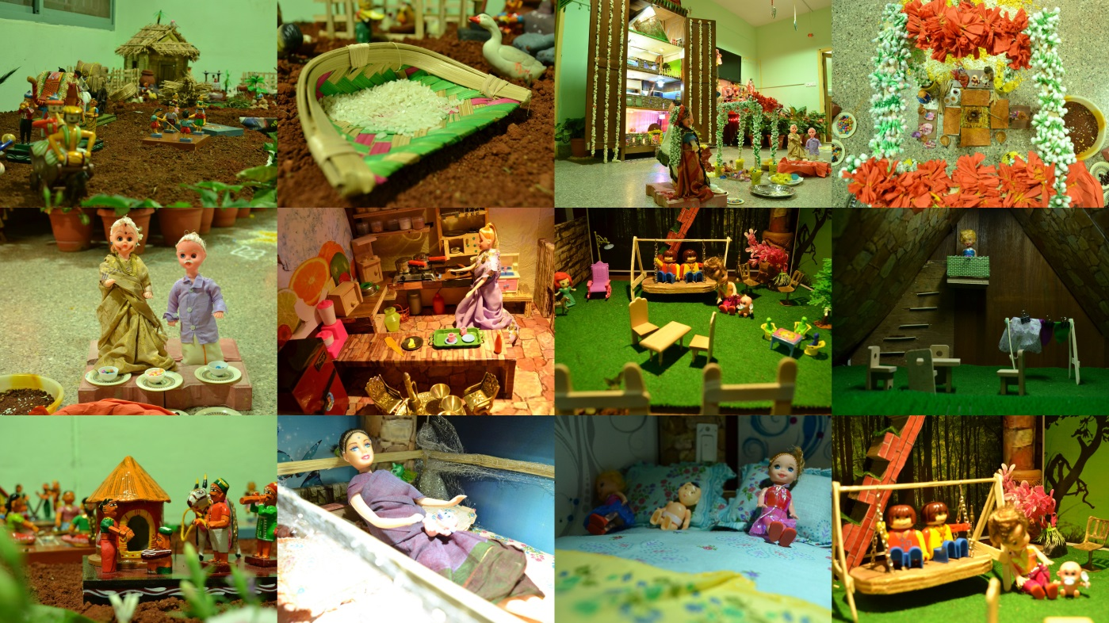

- Name of the Programme/ Event: Onam & Eid Celebration in Preschool
- Date: 28.09.2016
- Coordinators –Ms.Srividya M. S.
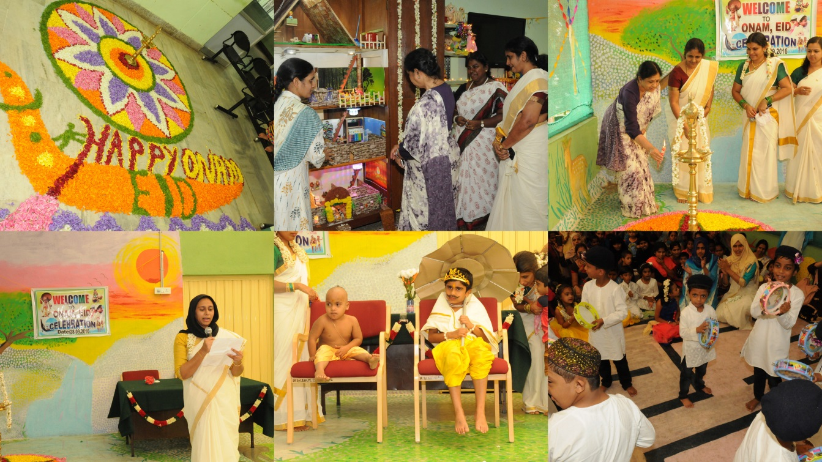

- Press Releases and Media Coverage
- Institute Publications -
- Material Development
Sl.  No. | Nature of Teaching-Learning Materials | Skill | Number
1. | Flash cards | For all skill areas | 173 sets
2. | Work Cards | For all skill areas | 48 sets
3. | Charts | For all skill areas | 10 sets
4. | PPT | For all skill areas | 22
5. | Models | For all skill areas | 10 sets
6. | Sentence strips | For all skill areas | 94 sets
7. | Others | For all skill areas | --

- AWARDS AND HONORS RECEIVED BY FACULTY AND STAFF
- EXTRA CURRICULAR ACTIVITIES
- Others:
    - The preschool children participated in the following extracurricular activities/celebrations
IX. EMINENT VISITORS: NIL
X. ANY OTHER
- Official Language Implementation:
- One word a day in Hindi.
- Department won prize for maximum official work done in Hindi (2015-16) during the Hindi week celebrations 2016

- PARENTS ENRICHMENT PROGRAMME (PEP): 01
Theme/Topic | “Hearing Mechanism” by Mr. Prashanth Prabhu
Coordinator | Mr. Subramanya K.R
Objectives | To give awareness about caregivers literacy training programme
Organized by Department/Section/Unit | Department of Special Education
Targeted Audience | Parents/Caregivers
Date | 14th September 2016
Photo | 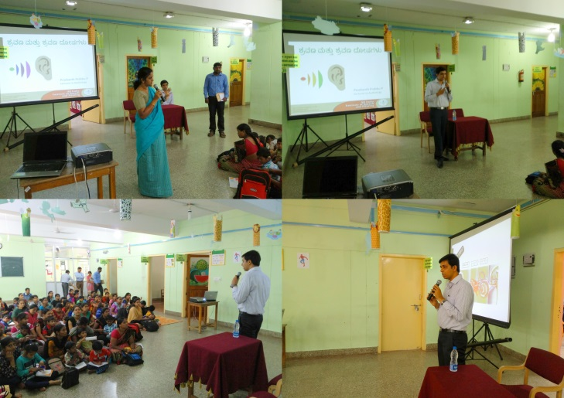

- Ms. Sumana H.P
- Served as EXTERNAL PRACTICAL EXAMINER for final year Diploma Special Education (HI)-Practicum 1of Govt. Teachers training Centre, at Mercy convent organised by AYJNIHH on 20th & 21st Sept 2016.

Sd/-
Dr. M. Pushpavathi
HOD – Special Education

